CONTRIBUTING TO writing.wvu.edu
Please celebrate the importance of writing in all our lives by contributing something to WVU’s space within the National Gallery of Writing. The process takes about 5-10 minutes since the site is, in addition to creating an archive, trying to get a sense of when and how people write today.
When you log onto the writing.wvu.edu website, you will see a screen that looks something like this:
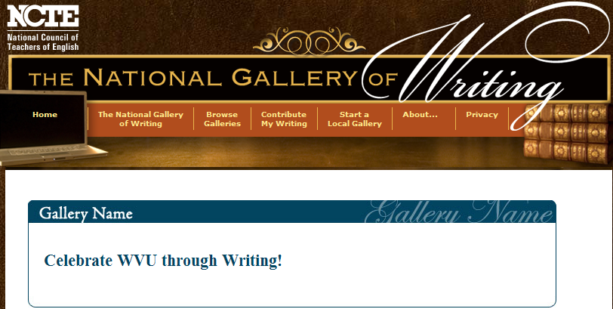
Scroll to the bottom of the page and click on the “contribute” button:

You will next be asked to create a profile:
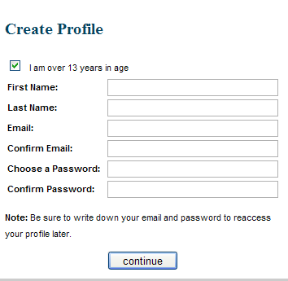

As you continue, you will be asked for contact information for archiving purposes.
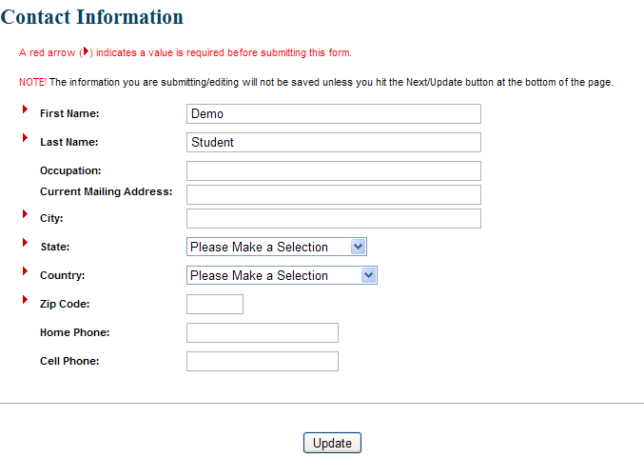

Once you have a profile, you will get a new welcome screen. Scroll to the CONTRIBUTE button.
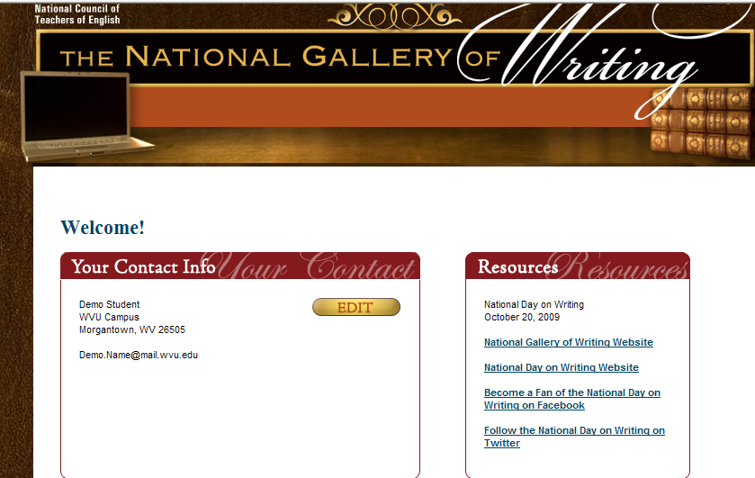
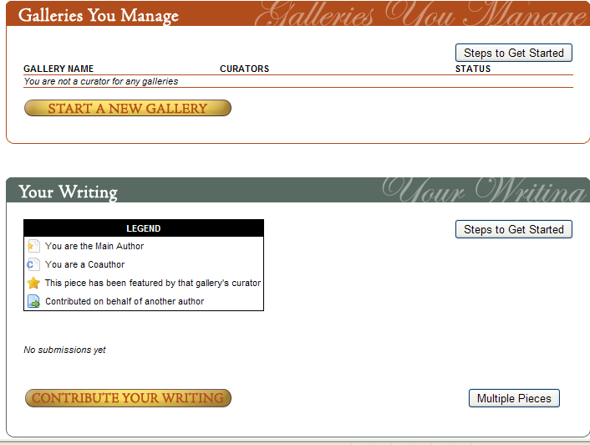  CONTRIBUTE (lower left)
After clicking on the “contribute your writing” button, you will see three permission statements. After completing each page, don't forget to click the Next button at the bottom of each page.
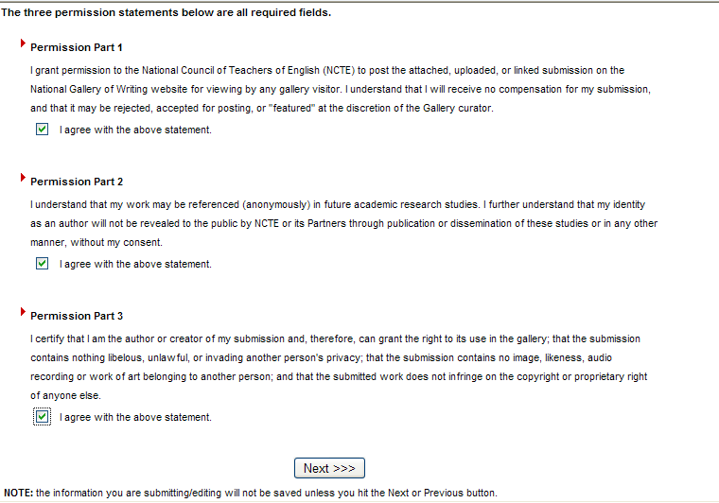
Next, you will be asked to say a bit more about yourself and your writing.
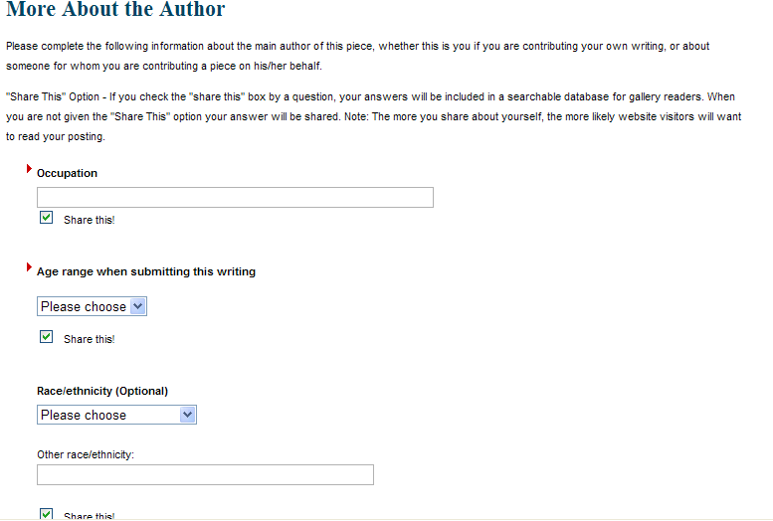
⇑ Share this?
As you complete these pages, you will be asked whether or not you would like to share certain information. If you click the Share This button, the information will appear in the National Gallery of Writing. If you leave that button unchecked, the information will not appear.
You will also be asked to provide a little information about your piece of writing. Again, you can choose whether or not you want to share the information in the National Gallery of Writing.
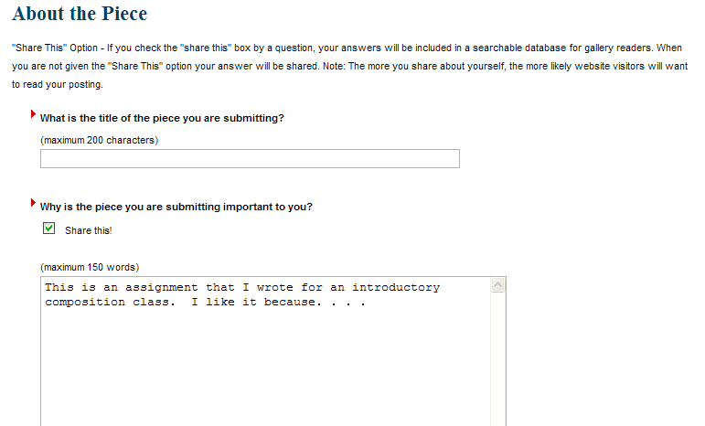

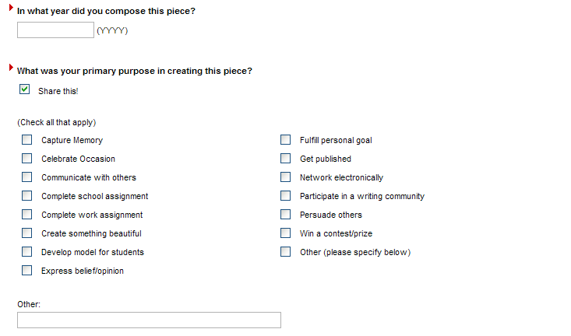
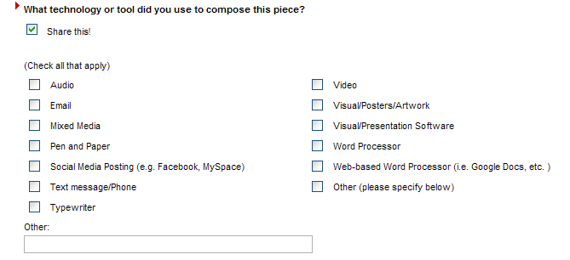
Notice that these questions about purpose, technology, audience, and genre will help develop a national profile of why, how, when, and what people write.
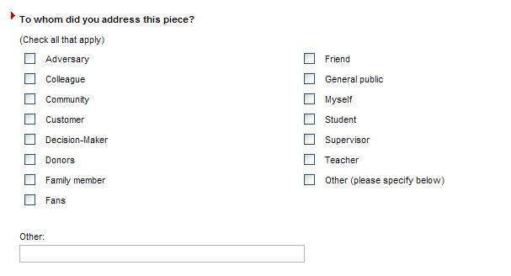
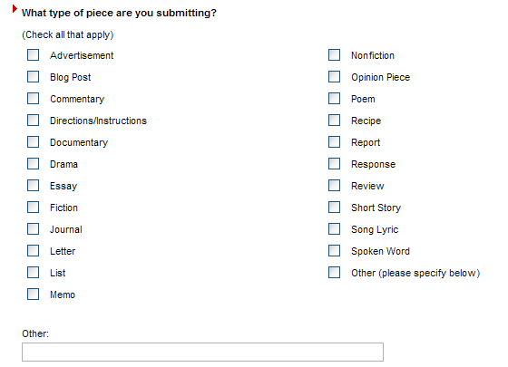

After completing the two pages about the author and about the piece, you can always return to the page, make additional edits, and then click Update.
CHOOSING A GALLERY
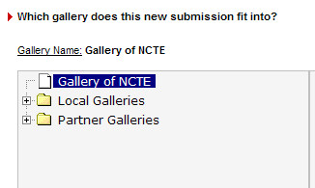

There are many, many galleries around the country that are all collecting writing. To help demonstrate the value of writing at WVU, you want to click on:
→
And then scroll down until you see

When you have chosen “Celebrate WVU through Writing,” you can upload your piece. You have three options. Most people will choose one of the first two options.

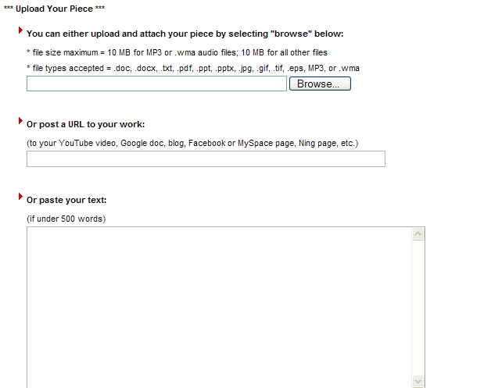

Once you have finished making updates and you are ready to submit your contribution, you should click the Click Here to Complete Your Submission button. You will NOT be able to make changes to your submission after you select this link.


