Introduction
This planning tool helps you gather the pieces needed for one piece of quality online learning. Including these pieces helps your course meet state and regional requirements.
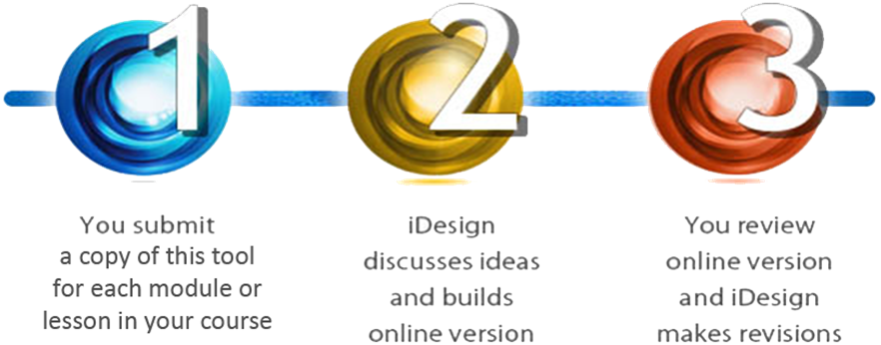
This tool is step 1 in the WVU iDesign Course Development Process.
You may already have some of the needed course content:
- You can use your PowerPoint presentations and lecture notes as a starting point.
- Next, flesh these out with text that shares the information you would usually present in a face-to-face lecture. Include your stories, experiences, explanations, and demonstrations. This is a key place where your expertise and experience add value to the course.
- Add logical headings and suggestions for media to the Learning Module Tool.
- Discuss ideas for how to handle instructional problems with your iDesign team member.
- Submit the content to the iDesign team member.

Things to Remember When Writing Course Content
- PowerPoints are not online course content. They are in-person visual aids.
- The PowerPoint is not the content; the talk is the content.
- List the source of each image (include a web address, book, etc.) so iDesign can check the copyright status for course usability.
- If you are uncertain how to handle an activity in an online setting, brainstorm with your iDesign team member.
- WVU Faculty Senate requires 45 contact hours, (in-class time) for a student to earn 3 credits. Homework or other activities that students do outside of the eCampus course do not count.
- The State of West Virginia now requires all online classes to meet the Quality Matters standards. Some of the course components you will add to this document will help you meet these requirements.
- Federal law prohibits sending student grades through outside systems, including e-mail.
- Federal law requires all online materials be made Accessible to those with disabilities. Your iDesign team member may ask you for text version of information or other items to meet this requirement.

Module Title/Overview (QM 4.2)

Enter the Title of your Module below:

Enter 2-3 Module Overview Paragraphs below:

Learning Objectives (QM General Standard 2)
Sample Measurable Objectives:
By the end of this module, students will be able to:
- Discuss the social implications of the New Deal policies.
- Analyze the dissemination of new inventions through populations.
- Describe the way shutter speed affects a final photograph.

Enter 3-5 simple objectives that are measured by graded activities below:
By the end of this module, students will be able to:

Activities Checklist

Enter a brief list of all graded and ungraded activities in this module, below (you will provide more detail later).
Sample Activities:
- Graded Discussion
- Required Reading
- Watching Videos
- Exams/Quizzes
- Review Questions / Puzzles
- Journals
- Papers
- Simulations

Module Activities Checklist:

Student to Content Interaction screens (QM 4.4, 4.5, 4.6, 5.1, 5.2, 5.3, 6.1, 6.2 )

Paste in your narrative explanations of (and examples of), the concepts students will learn in this module (what you would lecture about in a classroom) into the red box below.

Use headers to break this up into separate “computer screen” sized content chunks (250-300 words per screen; 20-25 screens total).

Please note the source of all images, and put a link to them when possible (QM 4.3).

Put any notes to your iDesign team in curly brackets: {like this!}

Student to Student Interaction (QM 4.4, 4.5, 4.6, 5.1, 5.4))

Paste your group activities, graded discussions, journals, etc. below.

Tip: Remember that discussions are not essay questions. You want to trigger conversation, not an essay. Ask yourself: “Can 20 people contribute to this topic without saying ‘me too’?”

Student to Instructor Interaction (QM 4.4, 4.5, 4.6, 5.1, 5.3)

List student-to-Instructor activities below. Consider activities such as journals, which are only visible to the student and instructor. Also consider any chat/review/q&a sessions that you might include. Include required response times for students and for the instructor.

Homework (QM 3.1, 3.3, 3.4, 3.5)

Paste in any assignments students must go do outside of class below (research, reading, etc.).

Remember: Homework does NOT count towards the 45 required contact hours in a 3 credit course!

Assessments (QM 3.1, 3.3, 3.4, 3.5)

List quizzes, exams, projects, portfolios, etc.

E-mail files for these items to your Instructional Designer.

Reminders
As you finish collecting materials for this module, double check that you have included these items:
- Measurable Learning Objectives
- Introduction/Overview
- Does your Activities Checklist include all student work, both graded and ungraded?
- Do your pages of Student-Content Interaction have headers on each page?
- Did you add a link or source for any images, videos, or audio?
  - Remember to send your Instructional Designer any audio or video clips via e-mail/dropbox/mailing a CD.
  - Did you note which screen a particular video or audio file should be included on?
- Did you include student-student activity details?
- Remember to e-mail quizzes, exams, etc. to your Instructional Designer, with the correct answers marked, if applicable.
- Remember to e-mail rubrics or grading criteria for all activities to your Instructional Designer.

