

Laboratory Report

MECHANICAL MEASUREMENTS

Name of Instructor Dr. Bettig

Name of Student David Green

Class MAE 333 Dep’t. or Section 01

WEST VIRGINIA UNIVERSITY INSTITUTE OF TECHNOLOGY

Title TEMPERATURE OF ALUMINUM

Date of Experiment August 30, 2014 No. of Experiment 1

Partner’s Name

Date Returned for Revision

Date Accepted

Date Received

Instructor’s Initials

# Abstract

An experiment was performed to understand/determine/measure … *(state the physical quantity of interest)*. The experiment was performed by … *(summarize the procedure in one or two phrases)* using … *(state the type of equipment used)*. It was found that … *(state the primary or interesting results from the experiment)*.

# Introduction

*Start the introduction with a sentence or two that connects the reader with the topic, to provide a context of the experiment to the reader. It should be something like:*

Temperature is a physical quantity that is important for the operation of most mechanical equipment. *Now state the purpose of the experiment:* The purpose of this experiment was to understand/determine/measure … *(state the physical quantity of interest)*. The experiment was performed by … *(summarize the procedure in one or two phrases)* using … *(state the type of equipment used)*. *It’s ok if the wording is the same as the abstract. Now explain the organization of the report:* This report first explains the theory behind the measurement, then …

# Theory

*For most reports it is helpful to provide a separate section that familiarizes the reader with the background concepts and published literature relevant to the investigation. For this course, the report must include a “Theory” section to serve this purpose. All measurement devices involve using a physical principle to convert a physical quantity that is not directly observable to another physical quantity that can be read off a scale or read electronically. A theoretical model, usually in the form of an equation, relates the quantity being measured to the quantity that can be observed. The theoretical model should therefore be explained something like this example:*

A mercury thermometer uses the principle of expansion of mercury with temperature to enable showing the temperature on a scale. The relationship between the volume (*V*) and temperature (*T*) is represented by the volumetric thermal expansion coefficient (α*V*) through the equation[1]:

If the mercury is only in a tube of constant cross-section and the coefficient is assumed to be constant then:

Δ*L* = α*V* *L*0 Δ*T*

where:

Δ*L* is the change in length of the column of mercury in the tube

*L*0 is the initial length of the column of mercury in the tube

α*V* is the volumetric thermal expansion coefficient

Δ*T* is the change in temperature.

Δ*L* can be observed directly and can be correlated to the temperature through the scale that is placed next to the column of mercury as shown in Figure 1.

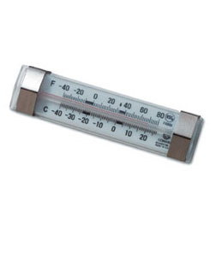

(image from Mission Restaurant Supply)

**Figure 1. A Mercury Thermometer**

*Most modern measurement equipment uses different physical principles that convert the quantity being measured to an electric signal whose voltage, current or other property is converted to digital form and then displayed on a dedicated readout or sent to a computer for further processing and storage. Here the theoretical model may be unknown or too complicated to explain mathematically, so just a description of the model may suffice, as shown in this example:*

Figure 2 shows a modern thermometer based on a “thermister” whose electrical resistance changes with temperature. Changes in resistance are detected as changes in voltage. The voltage is converted to digital form through an “analog-to-digital” converter and the digital quantity is multiplied by a constant to get the temperature, which is shown on the LCD display. [2,3]

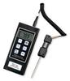

(image from Granger Industrial Supply)

**Figure 2. A Thermister Thermometer Probe and LCD Display**

# Method

*First go over the equipment that was used.*

The equipment used in this experiment included:

* _______,
* _______, and
* _______.

Figure 3 shows a schematic view of the equipment setup. The ___ is used to … The ___ is used to … *Explain the components of the measurement apparatus shown in the figure in 2-3 sentences.*

*The equipment setup should be shown as a line diagram or schematic. Showing a photograph of the actual layout is also possible, but it is usually easier to make sense of the setup in a line drawing or schematic. It may then be helpful to show photographs of individual components of the apparatus in the context of the layout.*

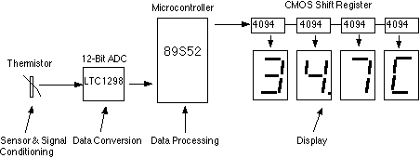

(image from Wichit Sirichote)

**Figure 3. Schematic of Thermister Thermometer Used in this Experiment**

*Then provide and explain the procedure used.*

In order to measure the ______, the following procedure was followed:

1. Do something using some equipment
2. Do something else using some equipment

# Results

The raw data recorded in Step 2 of the procedure is shown in Table 1. Each row corresponds to a different ____. The first column shows ____. The second column gives ____. …

**Table 1. Raw Recorded Values for _____**

|  |  |  |  |  |
| --- | --- | --- | --- | --- |
| **Trial** | **Data X1 (mm)** | **Data X2 (mm)** | **Data X3 (mm)** | **Comments** |
| Initial run | … |  |  |  |
|  |  |  |  |  |
|  |  |  |  |  |

The ___ was converted to ____ by multiplying … The results for each ____ are shown in Table 2 and are plotted in Figures 4 and 5. Sample calculations are shown in Figure 6 for the first set of readings.

*In many cases it might be good to combine Tables 1 and 2. A “Comments” column is usually not necessary. If there are a lot of data points or it is not necessary to know the exact values then just plotting them is good enough; the values do not need to appear in a table.*

**Table 2. Computed Results for _______**

|  |  |  |  |  |
| --- | --- | --- | --- | --- |
| **Trial** | **Data X1 (mm)** | **Results Y1 (ºC)** | **Results Z1 (ºK)** | **Comments** |
| Initial run | … |  |  |  |
|  |  |  |  |  |
|  |  |  |  |  |

*Important: the number of significant digits for values in the table must match the level of accuracy with which the values are known. (E.g., if the reading resolution is 0.5 or the least count is 0.5 or the standard deviation is 0.5, then a value of 23.52765723 must be rounded to at least 23.5.)*

|  |  |
| --- | --- |
|  |  |
| (a) | (b) |

**Figure 4. Plot of ____ (a) with __ and (b) with ___**

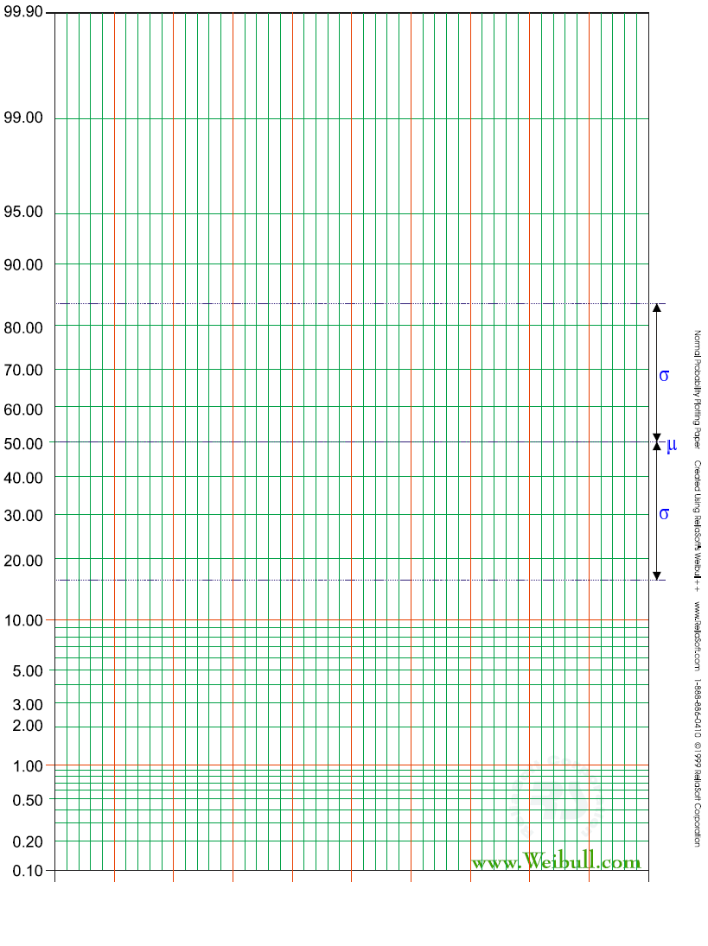

60

70

80

90

100

110

120

130

140

(m/s)

**Figure 5. Cumulative Probability Distribution for xxx**

|  |  |
| --- | --- |
| *X* = 5 mm | *X* is the ____ |
| $$Y=\frac{100X+50}{\sum{X}}$$ $$=\frac{100∙5+50}{\left(5+0+0+0\right)}$$ = 10° C | *Y* is the ____ |

**Figure 6. Sample Calculations for xxx**

# Discussion

*Include observations and answer the questions from the lab manual.*

# References

1. Wikipedia, “Thermal Expansion,” Wikimedia Foundation, Inc., (accessed Sept. 16, 2013; http://en.wikipedia.org/wiki/Thermal_expansion)
2. WVU Tech, “Laboratory Manual – MAE-333: Mechanical Measurements,” West Virginia University Institute of Technology, Montgomery, WV, 2013.
3. J.P. Holman, *Experimental Methods for Engineers*, 7th Edition, McGraw-Hill, 2001.

*The References section should only cite references where you got specific information that you used in the report. Pictures you obtained (did not create yourself) normally should be credited at the picture as shown in Figures 1-3. Each reference that is listed in this section must have a corresponding bracketed number in the body of the report where the information is used. If no references were used, this section is not necessary.*