West Virginia University
College of Engineering and Mineral Resources
Lane Dept. of Computer Science and Electrical Engineering

CpE 484 – Real Time Systems
Implementation and Testing
10 May 2002

Submitted by: | Andrew Golden
 | Matthew Kile
 | Joshua Kraan
 | Joshua Robinson

Table of Contents

Introduction 1
Structure Chart 1
Implementation Details 3
Testing 3
Results 9
Reflection 9
Appendix A 11
Appendix B 23

Introduction
This report describes the steps taken for implementation and testing of a subsection of the Automated Commuter Train project. The aforementioned subsystem is the speed control module of the Train Operation System. This component is responsible for reacting to changes in the track, responding to emergency situations, and stopping at designated stations.

Structure Chart
During the design phase, the structure chart shown in Figure 1 was created for the speed control subsystem. The on-page connectors reference the functions listed below. These functions are part of data-hiding modules.

On-page Connector  Number | Referenced Function
2 | Get Itinerary
5 | Put Run-Log
8 | Get Track data

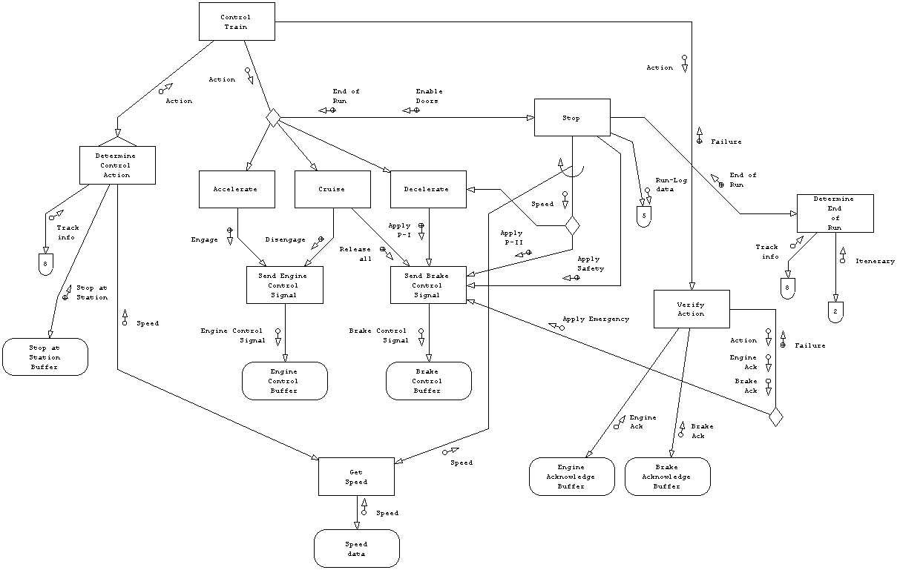
Figure 1: Structure Chart
Implementation Details
To test this module, all of its functions were coded according to the M-Specs. The language used was C, and the code was compiled using the GNU gcc compiler. The modules are declared in control.h and defined in control.c. See Appendix A for the complete source listing.
Hardware buffers and data-hiding modules are global and implemented in main.h. Because of this, the test driver can easily set up conditions for a test case and check the values set by the tested module. The variable that keeps track of the current state is also global.
The test driver functionality is accomplished in the main() function of main.c. This function performs each of the test cases (described later) and prints the results to the screen. These results may be easily saved to a file using indirection, as both Windows and Linux support this capability.

Testing
The goal of testing is to ensure that the system responds correctly to conditions set by the test driver. In this case, the effects being watched are the signals being sent to the engine and brake systems. The following chart lists causes and effects used for creating test cases.

Causes | Effects
c1: state = cruising | e1: set state = cruising
c2: state = accelerating | e2: set state = accelerating
c3: state = decelerating | e3: set state = decelerating
c4: state = stopping | e4: set state = stopping
c5: state = stopped | e5: set state = stopped
c10: start_train | e10: engage engine
c11: no engine_ack | e11: disengage engine
c12: no brake_ack | e12: release all brakes
c13: stop at station | e13: apply Phase-I brakes
c14: approaching station | e14: apply Phase-II brakes
c15: end of itinerary reached | e15: apply safety brake
c100: speed >= max speed | e16: apply emergency brake
c101: speed <= min speed | e100: set end of run
c102: speed = max speed
c103: speed = 0
c104: speed <= PII_SPEED

With the causes and effects defined, test cases could be created. This was done using cause-effect graphs. Note that e1 through e5 are intermediate effects, and thus are not shown on the decision table that was later generated from the cause-effect graphs. However, the program does display the state for each test case.
The cause-effect graphs are shown below, followed by the decision table.
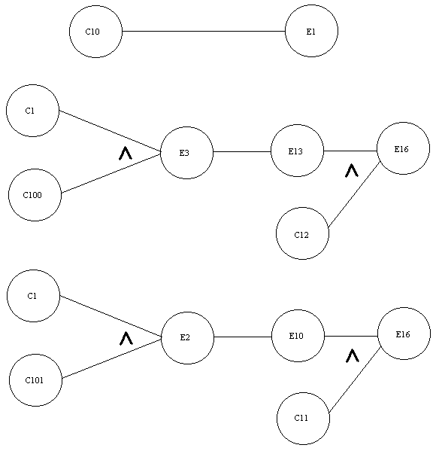
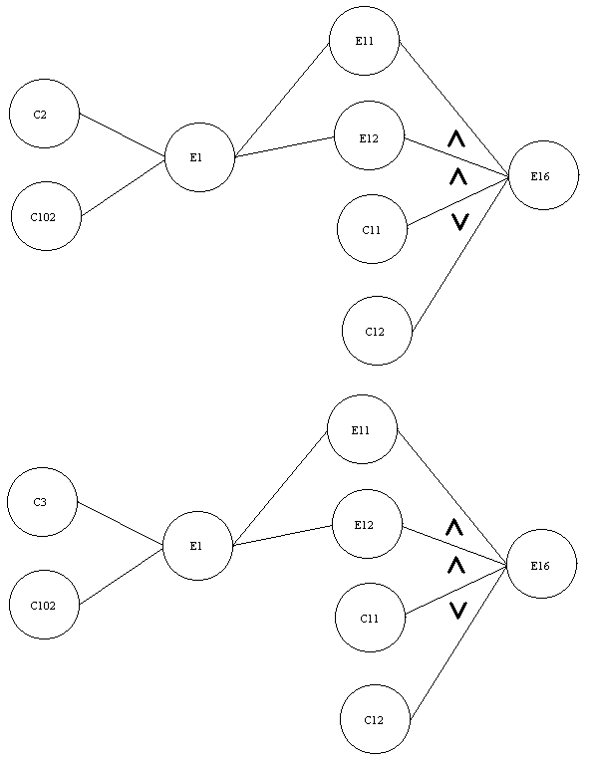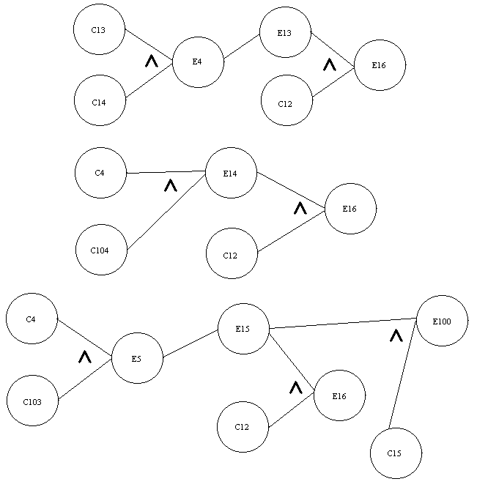
Results
The program successfully compiles and runs in a Linux environment. Observing the output, all test cases were successful. The output was redirected to a file, which is included in Appendix B.

Reflection
Over the course of the semester, we as a group gained new knowledge and skills from our experience with the project. While there is no doubt as to the importance of classroom learning, projects present an opportunity for students to work together and apply the concepts in a more practical environment.
For many programming assignments, students can simply sit down, begin coding, debug as they go, and come up with an acceptable result. No proof of planning or forethought is required. While this is effective for small class assignments, it certainly is unacceptable in industry. Thus, it was a beneficial requirement to complete a project following a lifecycle model because it made us think about the entire development process.
During the analysis phase, we as a group had to think very high-level. This was difficult for us, being more used to writing code or, at the most, making flowcharts. Shifting to a more conceptual view of the project forced us to think more about interactions with external modules.
The design phase was much easier because it involved thinking about functions and parameter passing. This was much more natural for us. Because of our frame of mind during the analysis, converting the data flow diagrams to structure charts was very smooth. We did have to learn the proper procedure for diagramming our design, though.
Implementation and testing was by far the easiest part of the project for us, since we are all accustomed to writing code. Learning the proper techniques for creating a test scenario was very helpful and sped up the coding.
Appendix A – Source Code
// control.h
// Group 2
// Andrew Golden, Joshua Kraan
// Matthew Kile, Joshua Robinson
// CpE 484 - Real Time Systems
// West Virginia University
// May 10, 2002
#include "main.h"

int speed;

void control_train(void);
void accelerate(void);
void cruise(void);
void decelerate(void);
void stop(void);
int send_engine_control(int engine_control_signal);
void send_brake_control(int brake_control_signal);
int failure;
int verify_action(int action);
int get_speed(void);
void put_run_log (int run_log);
int determine_end_of_run(void);
// control.c
// Group 2
// Andrew Golden, Joshua Kraan
// Matthew Kile, Joshua Robinson
// CpE 484 - Real Time Systems
// West Virginia University
// May 10, 2002
#include "control.h"

void control_train(void)
{
int action;
int max_speed;
int min_speed;
int stop_request;
int speed;
int verify;
// determine control action:
// track info from buffer
max_speed = track_info.max_speed;
min_speed = track_info.min_speed;
// stop at station from buffer
stop_request = stop_at_station;
// get speed
speed = get_speed();
// return action

if (stop_request != FALSE)
{
action = STOPPING;
state = action;
stop();
}
else if (speed > max_speed)
{
action = DECELERATE;
state = action;
while (speed_data > track_info.max_speed)
decelerate();
}
else if (speed < min_speed)
{
action = ACCELERATE;
state = action;
while (speed_data < track_info.max_speed)
accelerate();
}
else if (speed >= min_speed && speed <= max_speed)
{
action = CRUISE;
state = action;
cruise();
}
else
{
action = FAIL;
state = action;
printf("Warning: control_train module entered undefined action mode.\n");
}
// verify action
verify = verify_action(action);
}

void accelerate(void)
{
failure = send_engine_control(ENGAGE);
if (failure != FALSE)
printf ("Warning: send_engine_control failed.\n");
}

void cruise(void)
{
state = CRUISE;
failure = send_engine_control(DISENGAGE);

send_brake_control(RELEASE);
}

void decelerate(void)
{
send_brake_control(PHASE_I);
}

void stop(void)
{
speed = get_speed();
if (speed > PHASE_I_MIN_SPEED)
{
printf("decelerating from stop...\n");
decelerate();
}
else if (speed == 0)
{
send_brake_control(SAFETY);
put_run_log (track_info.station_id);
end_of_run = determine_end_of_run();
enable_doors = TRUE;
state = STOPPED;
}
else
{
send_brake_control(PHASE_II);
}
}

int send_engine_control( int engine_control_signal)
{
int failure = FAIL; // assume failure, prove safe later

if ( enable_doors == FALSE &&
enable_motion == TRUE)
{
engine_control = engine_control_signal;
speed_data++; // ***USED FOR TESTING ONLY***
failure = FALSE;
}
return failure;
}

void send_brake_control( int brake_control_signal)
{
if (brake_acknowledge == FALSE)
{
brake_control_signal = EMERGENCY;
speed_data = 0; // ***PRETEND EMRG WORKS***
}
else
{
speed_data--; // ***USED FOR TESTING ONLY***
if (speed_data < 0) speed_data = 0;
}
brake_control = brake_control_signal;
}

int verify_action( int action)
{
int fail = FAIL; // assume failure, prove safe later
switch (action)
{
case STOPPING:
if ( engine_acknowledge == TRUE &&
brake_acknowledge == TRUE)
failure = FALSE;
else
failure = STOPPING;
break;
case STOPPED:
if ( engine_acknowledge == TRUE &&
brake_acknowledge == TRUE)
failure = FALSE;
else
failure = STOPPED;
break;
case ACCELERATE:
if ( engine_acknowledge == TRUE &&
brake_acknowledge == TRUE)
failure = FALSE;
else
failure = ACCELERATE;
break;
case DECELERATE:
if ( engine_acknowledge == TRUE &&
brake_acknowledge == TRUE)
failure = FALSE;
else
failure = DECELERATE;
break;
case CRUISE:
if ( engine_acknowledge == TRUE &&
brake_acknowledge == TRUE)
failure = FALSE;
else
failure = CRUISE;
break;
case FAIL:
printf("Error: unable to verify undefined action.\n");
break;
default:
printf("Warning: verify_action module entered undefined action mode.\n");
break;
}
if (failure != FALSE)
send_brake_control(EMERGENCY);
return failure;
}

int get_speed(void)
{
return speed_data;
}

void put_run_log(int run_log)
{
run_log_data += run_log;
}

int determine_end_of_run(void)
{
int EOR = FALSE;
if (track_info.station_id == itenerary.last_station_id)
{
EOR = TRUE;
}
return EOR;
}
// main.h
// Group 2
// Andrew Golden, Joshua Kraan
// Matthew Kile, Joshua Robinson
// CpE 484 - Real Time Systems
// West Virginia University
// May 10, 2002

#define FALSE 0
#define TRUE 1
#define DISENGAGE 0
#define ENGAGE 1
#define DISABLE 0
#define ENABLE 1
#define FAIL -1
#define STOPPING 1
#define STOPPED 2
#define ACCELERATE 3
#define DECELERATE 4
#define CRUISE 5
#define RELEASE 0
#define PHASE_I 1
#define PHASE_II 2
#define SAFETY 3
#define EMERGENCY 4
#define PHASE_I_MIN_SPEED 30

struct info_packet
{
int approaching_station;
int max_speed;
int min_speed;
int station_id;
};

struct itenerary_packet
{
int stations;
int last_station_id;
};

struct info_packet track_info;
struct itenerary_packet itenerary;

int brake_acknowledge;
int brake_control;
int enable_doors;
int enable_motion;
int end_of_run;
int engine_acknowledge;
int engine_control;
int run_log_data;
int speed_data;
int state;
int stop_at_station;

void reset(void);
void report_test_results(int test_case);
// main.c
// Main procedure for the executable: train
// Use the command make on a Unix system to compile.
// Enter ./train to execute.
//
// Group 2
// Andrew Golden, Joshua Kraan
// Matthew Kile, Joshua Robinson
// CpE 484 - Real Time Systems
// West Virginia University
// May 10, 2002
#include <stdio.h>
#include "main.h"

void reset();
void report_test_results(int test_case);

int main()
{
// Initialize variables.
// Since we have no actual external system continually
// dumping track info to us, we're just making this up
// here, for the sake of testing.

int test_case;
reset();
printf("Initial values:\n\n");
report_test_results(0);

test_case = 1;
reset();
cruise();
speed_data = track_info.max_speed + 5; // speed >= max speed
brake_acknowledge = TRUE; // brakes work
control_train();
report_test_results(test_case);

test_case = 2;
reset();
cruise();
speed_data = track_info.max_speed + 5; // speed >= max speed
brake_acknowledge = FALSE; // brakes fail
control_train();
report_test_results(test_case);

test_case = 3;
reset();
cruise();
speed_data = track_info.min_speed - 5; // speed <= min speed
engine_acknowledge = TRUE; // engine works
control_train();
report_test_results(test_case);

test_case = 4;
reset();
cruise();
speed_data = track_info.min_speed - 5; // speed <= min speed
engine_acknowledge = FALSE; // engine fail
control_train();
report_test_results(test_case);

test_case = 5;
reset();
accelerate();
speed_data = track_info.max_speed; // speed = max speed
engine_acknowledge = TRUE; // engine fail
control_train();
report_test_results(test_case);

test_case = 6;
reset();
accelerate();
speed_data = track_info.max_speed; // speed = max speed
engine_acknowledge = FALSE; // engine fail
control_train();
report_test_results(test_case);

test_case = 7;
reset();
accelerate();
speed_data = track_info.max_speed; // speed = max speed
brake_acknowledge = FALSE;
control_train();
report_test_results(test_case);

test_case = 8;
reset();
accelerate();
speed_data = track_info.max_speed; // speed = max speed
engine_acknowledge = FALSE; // engine fail
brake_acknowledge = FALSE;
control_train();
report_test_results(test_case);

test_case = 9;
reset();
decelerate();
speed_data = track_info.max_speed; // speed = max speed
control_train();
report_test_results(test_case);

test_case = 10;
reset();
decelerate();
speed_data = track_info.max_speed;
engine_acknowledge = FALSE;
control_train();
report_test_results(test_case);

test_case = 11;
reset();
decelerate();
speed_data = track_info.max_speed;
brake_acknowledge = FALSE;
control_train();
report_test_results(test_case);

test_case = 12;
reset();
decelerate();
speed_data = track_info.max_speed;
engine_acknowledge = FALSE;
brake_acknowledge = FALSE;
control_train();
report_test_results(test_case);

test_case = 13;
reset();
speed_data = 45;
stop_at_station = TRUE;
track_info.approaching_station = TRUE;
control_train();
report_test_results(test_case);

test_case = 14;
reset();
speed_data = 45;
stop_at_station = TRUE;
track_info.approaching_station = TRUE;
brake_acknowledge = FALSE;
control_train();
report_test_results(test_case);

test_case = 15;
reset();
speed_data = PHASE_I_MIN_SPEED - 5;
stop_at_station = TRUE;
track_info.approaching_station = TRUE;
control_train();
report_test_results(test_case);

test_case = 16;
reset();
speed_data = PHASE_I_MIN_SPEED - 5;
stop_at_station = TRUE;
track_info.approaching_station = TRUE;
brake_acknowledge = FALSE;
control_train();
report_test_results(test_case);

test_case = 17;
reset();
speed_data = 0;
stop_at_station = TRUE;
track_info.approaching_station = TRUE;
control_train();
report_test_results(test_case);

test_case = 18;
reset();
speed_data = 0;
stop_at_station = TRUE;
track_info.approaching_station = TRUE;
brake_acknowledge = FALSE;
control_train();
report_test_results(test_case);

test_case = 19;
reset();
speed_data = 0;
stop_at_station = TRUE;
track_info.approaching_station = TRUE;
track_info.station_id = itenerary.last_station_id;
control_train();
report_test_results(test_case);

return 0;
}

void reset() // initialize default values
{
track_info.approaching_station = FALSE;
track_info.max_speed = 55;
track_info.min_speed = 30;
track_info.station_id = 2;
itenerary.stations = 6;
itenerary.last_station_id = 4;
brake_acknowledge = TRUE;
brake_control = RELEASE;
enable_doors = FALSE;
enable_motion = TRUE;
end_of_run = FALSE;
engine_acknowledge = TRUE;
engine_control = CRUISE;
run_log_data = 0;
speed_data = 0;
state = CRUISE;
stop_at_station = FALSE;
}

void report_test_results(int test_case)
{
printf ("Test case %d: \n", test_case);
printf ("track_info: approaching station = %d\n",track_info.approaching_station);
printf (" max_speed . = %d\n",track_info.max_speed);
printf (" min_speed . = %d\n",track_info.min_speed);
printf (" station_id . = %d\n",track_info.station_id);
printf ("itenerary: stations . = %d\n",itenerary.stations);
printf (" last_station_id . = %d\n",itenerary.last_station_id);
printf ("brake_acknowledge . . = %d\n",brake_acknowledge);
printf ("brake_control . . . = ");
switch (brake_control)
{
case RELEASE:
printf ("RELEASE\n");
break;
case PHASE_I:
printf ("PHASE_I\n");
break;
case PHASE_II:
printf ("PHASE_II\n");
break;
case SAFETY:
printf ("SAFETY\n");
break;
case EMERGENCY:
printf ("EMERGENCY\n");
break;
default:
printf ("***UNDEFINED***");
break;
}
printf ("endable_doors . . . = %d\n",enable_doors);
printf ("enable_motion . . . = %d\n",enable_motion);
printf ("end_of_run . . . = %d\n",end_of_run);
printf ("engine_acknowledge . . = %d\n",engine_acknowledge);
printf ("engine_control . . . = %d\n",engine_control);
printf ("run_log_data . . . = %d\n",run_log_data);
printf ("speed_data . . . = %d\n",speed_data);
printf ("state . . . . = ");
switch (state)
{
case STOPPING:
printf ("STOPPING\n");
break;
case STOPPED:
printf ("STOPPED\n");
break;
case ACCELERATE:
printf ("ACCELERATE\n");
break;
case DECELERATE:
printf ("DECELERATE\n");
break;
case CRUISE:
printf ("CRUISE\n");
break;
default:
printf ("***UNDEFINED***");
break;
}
printf ("stop_at_station . . . = %d\n\n\n",stop_at_station);
}
MAKEFILE

train : control.o main.o
gcc -o train control.o main.o

control.o : control.h control.c
gcc -c control.c

main.o : control.h control.c main.h main.c
gcc -c main.c

clean :
rm -f train *.o *~
Appendix B – Testing Results

Initial values:

Test case 0:
track_info: approaching station = 0
max_speed . = 55
min_speed . = 30
station_id . = 2
itenerary: stations . = 6
last_station_id . = 4
brake_acknowledge . . = 1
brake_control . . . = RELEASE
endable_doors . . . = 0
enable_motion . . . = 1
end_of_run . . . = 0
engine_acknowledge . . = 1
engine_control . . . = 5
run_log_data . . . = 0
speed_data . . . = 0
state . . . . = CRUISE
stop_at_station . . . = 0

Test case 1:
track_info: approaching station = 0
max_speed . = 55
min_speed . = 30
station_id . = 2
itenerary: stations . = 6
last_station_id . = 4
brake_acknowledge . . = 1
brake_control . . . = PHASE_I
endable_doors . . . = 0
enable_motion . . . = 1
end_of_run . . . = 0
engine_acknowledge . . = 1
engine_control . . . = 0
run_log_data . . . = 0
speed_data . . . = 55
state . . . . = DECELERATE
stop_at_station . . . = 0

Test case 2:
track_info: approaching station = 0
max_speed . = 55
min_speed . = 30
station_id . = 2
itenerary: stations . = 6
last_station_id . = 4
brake_acknowledge . . = 0
brake_control . . . = EMERGENCY
endable_doors . . . = 0
enable_motion . . . = 1
end_of_run . . . = 0
engine_acknowledge . . = 1
engine_control . . . = 0
run_log_data . . . = 0
speed_data . . . = 0
state . . . . = DECELERATE
stop_at_station . . . = 0

Test case 3:
track_info: approaching station = 0
max_speed . = 55
min_speed . = 30
station_id . = 2
itenerary: stations . = 6
last_station_id . = 4
brake_acknowledge . . = 1
brake_control . . . = RELEASE
endable_doors . . . = 0
enable_motion . . . = 1
end_of_run . . . = 0
engine_acknowledge . . = 1
engine_control . . . = 1
run_log_data . . . = 0
speed_data . . . = 55
state . . . . = ACCELERATE
stop_at_station . . . = 0

Test case 4:
track_info: approaching station = 0
max_speed . = 55
min_speed . = 30
station_id . = 2
itenerary: stations . = 6
last_station_id . = 4
brake_acknowledge . . = 1
brake_control . . . = EMERGENCY
endable_doors . . . = 0
enable_motion . . . = 1
end_of_run . . . = 0
engine_acknowledge . . = 0
engine_control . . . = 1
run_log_data . . . = 0
speed_data . . . = 54
state . . . . = ACCELERATE
stop_at_station . . . = 0

Test case 5:
track_info: approaching station = 0
max_speed . = 55
min_speed . = 30
station_id . = 2
itenerary: stations . = 6
last_station_id . = 4
brake_acknowledge . . = 1
brake_control . . . = RELEASE
endable_doors . . . = 0
enable_motion . . . = 1
end_of_run . . . = 0
engine_acknowledge . . = 1
engine_control . . . = 0
run_log_data . . . = 0
speed_data . . . = 55
state . . . . = CRUISE
stop_at_station . . . = 0

Test case 6:
track_info: approaching station = 0
max_speed . = 55
min_speed . = 30
station_id . = 2
itenerary: stations . = 6
last_station_id . = 4
brake_acknowledge . . = 1
brake_control . . . = EMERGENCY
endable_doors . . . = 0
enable_motion . . . = 1
end_of_run . . . = 0
engine_acknowledge . . = 0
engine_control . . . = 0
run_log_data . . . = 0
speed_data . . . = 54
state . . . . = CRUISE
stop_at_station . . . = 0

Test case 7:
track_info: approaching station = 0
max_speed . = 55
min_speed . = 30
station_id . = 2
itenerary: stations . = 6
last_station_id . = 4
brake_acknowledge . . = 0
brake_control . . . = EMERGENCY
endable_doors . . . = 0
enable_motion . . . = 1
end_of_run . . . = 0
engine_acknowledge . . = 1
engine_control . . . = 0
run_log_data . . . = 0
speed_data . . . = 0
state . . . . = CRUISE
stop_at_station . . . = 0

Test case 8:
track_info: approaching station = 0
max_speed . = 55
min_speed . = 30
station_id . = 2
itenerary: stations . = 6
last_station_id . = 4
brake_acknowledge . . = 0
brake_control . . . = EMERGENCY
endable_doors . . . = 0
enable_motion . . . = 1
end_of_run . . . = 0
engine_acknowledge . . = 0
engine_control . . . = 0
run_log_data . . . = 0
speed_data . . . = 0
state . . . . = CRUISE
stop_at_station . . . = 0

Test case 9:
track_info: approaching station = 0
max_speed . = 55
min_speed . = 30
station_id . = 2
itenerary: stations . = 6
last_station_id . = 4
brake_acknowledge . . = 1
brake_control . . . = RELEASE
endable_doors . . . = 0
enable_motion . . . = 1
end_of_run . . . = 0
engine_acknowledge . . = 1
engine_control . . . = 0
run_log_data . . . = 0
speed_data . . . = 55
state . . . . = CRUISE
stop_at_station . . . = 0

Test case 10:
track_info: approaching station = 0
max_speed . = 55
min_speed . = 30
station_id . = 2
itenerary: stations . = 6
last_station_id . = 4
brake_acknowledge . . = 1
brake_control . . . = EMERGENCY
endable_doors . . . = 0
enable_motion . . . = 1
end_of_run . . . = 0
engine_acknowledge . . = 0
engine_control . . . = 0
run_log_data . . . = 0
speed_data . . . = 54
state . . . . = CRUISE
stop_at_station . . . = 0

Test case 11:
track_info: approaching station = 0
max_speed . = 55
min_speed . = 30
station_id . = 2
itenerary: stations . = 6
last_station_id . = 4
brake_acknowledge . . = 0
brake_control . . . = EMERGENCY
endable_doors . . . = 0
enable_motion . . . = 1
end_of_run . . . = 0
engine_acknowledge . . = 1
engine_control . . . = 0
run_log_data . . . = 0
speed_data . . . = 0
state . . . . = CRUISE
stop_at_station . . . = 0

Test case 12:
track_info: approaching station = 0
max_speed . = 55
min_speed . = 30
station_id . = 2
itenerary: stations . = 6
last_station_id . = 4
brake_acknowledge . . = 0
brake_control . . . = EMERGENCY
endable_doors . . . = 0
enable_motion . . . = 1
end_of_run . . . = 0
engine_acknowledge . . = 0
engine_control . . . = 0
run_log_data . . . = 0
speed_data . . . = 0
state . . . . = CRUISE
stop_at_station . . . = 0

decelerating from stop...
Test case 13:
track_info: approaching station = 1
max_speed . = 55
min_speed . = 30
station_id . = 2
itenerary: stations . = 6
last_station_id . = 4
brake_acknowledge . . = 1
brake_control . . . = PHASE_I
endable_doors . . . = 0
enable_motion . . . = 1
end_of_run . . . = 0
engine_acknowledge . . = 1
engine_control . . . = 5
run_log_data . . . = 0
speed_data . . . = 44
state . . . . = STOPPING
stop_at_station . . . = 1

decelerating from stop...
Test case 14:
track_info: approaching station = 1
max_speed . = 55
min_speed . = 30
station_id . = 2
itenerary: stations . = 6
last_station_id . = 4
brake_acknowledge . . = 0
brake_control . . . = EMERGENCY
endable_doors . . . = 0
enable_motion . . . = 1
end_of_run . . . = 0
engine_acknowledge . . = 1
engine_control . . . = 5
run_log_data . . . = 0
speed_data . . . = 0
state . . . . = STOPPING
stop_at_station . . . = 1

Test case 15:
track_info: approaching station = 1
max_speed . = 55
min_speed . = 30
station_id . = 2
itenerary: stations . = 6
last_station_id . = 4
brake_acknowledge . . = 1
brake_control . . . = PHASE_II
endable_doors . . . = 0
enable_motion . . . = 1
end_of_run . . . = 0
engine_acknowledge . . = 1
engine_control . . . = 5
run_log_data . . . = 0
speed_data . . . = 24
state . . . . = STOPPING
stop_at_station . . . = 1

Test case 16:
track_info: approaching station = 1
max_speed . = 55
min_speed . = 30
station_id . = 2
itenerary: stations . = 6
last_station_id . = 4
brake_acknowledge . . = 0
brake_control . . . = EMERGENCY
endable_doors . . . = 0
enable_motion . . . = 1
end_of_run . . . = 0
engine_acknowledge . . = 1
engine_control . . . = 5
run_log_data . . . = 0
speed_data . . . = 0
state . . . . = STOPPING
stop_at_station . . . = 1

Test case 17:
track_info: approaching station = 1
max_speed . = 55
min_speed . = 30
station_id . = 2
itenerary: stations . = 6
last_station_id . = 4
brake_acknowledge . . = 1
brake_control . . . = SAFETY
endable_doors . . . = 1
enable_motion . . . = 1
end_of_run . . . = 0
engine_acknowledge . . = 1
engine_control . . . = 5
run_log_data . . . = 2
speed_data . . . = 0
state . . . . = STOPPED
stop_at_station . . . = 1

Test case 18:
track_info: approaching station = 1
max_speed . = 55
min_speed . = 30
station_id . = 2
itenerary: stations . = 6
last_station_id . = 4
brake_acknowledge . . = 0
brake_control . . . = EMERGENCY
endable_doors . . . = 1
enable_motion . . . = 1
end_of_run . . . = 0
engine_acknowledge . . = 1
engine_control . . . = 5
run_log_data . . . = 2
speed_data . . . = 0
state . . . . = STOPPED
stop_at_station . . . = 1

Test case 19:
track_info: approaching station = 1
max_speed . = 55
min_speed . = 30
station_id . = 4
itenerary: stations . = 6
last_station_id . = 4
brake_acknowledge . . = 1
brake_control . . . = SAFETY
endable_doors . . . = 1
enable_motion . . . = 1
end_of_run . . . = 1
engine_acknowledge . . = 1
engine_control . . . = 5
run_log_data . . . = 4
speed_data . . . = 0
state . . . . = STOPPED
stop_at_station . . . = 1

