Pacemaker Model Brief Description

A cardiac Pacemaker is an implanted device that assists cardiac functions when the underlying pathologies make the intrinsic heartbeats low. The Pacemaker runs in either a programming mode or in one of operational modes. During programming, the programmer specifies the type of the operation mode in which the device will work. The operation mode depends on whether the Atrium (A), Ventricle (V), or both are being monitored or paced. The programmer also specifies whether the pacing is inhibit (I), triggered (T), or dual (D). The first operation mode to discuss is AVI operation mode. In this mode, the Atrial portion (A) of the heart is paced (shocked), the Ventricular portion (V) of the heart is sensed (monitored), and the Atrial is only paced when a Ventricular sense does not occur; i.e., inhibited (I). Figure 1 shows the Pacemaker design model using a Real-Time Object Oriented Modeling (ROOM) actor diagram. ObjecTime simulation environment is used to implement executable models, which are necessary to validate the timing and deadline constraints and gather simulation statistics. Actors are used in ROOM to represent the structure of the model while a ROOMchart, which is based on statechart notation and semantics, models the behavior of each actor. Figure 2 shows the ROOMchart for the Atrial_Model. Sequence diagrams will be used to describe several operation scenarios for the Pacemaker: The programming mode, The AVI operation mode, The AAI operation mode, The AAT operation mode, The VVI operation mode and The VVT operation mode.

The Pacemaker consists of the following classes:
Reed_Switch (RS): A magnetically activated switch that must be closed before programming the device. The switch is used to avoid accidental programming by electric noise.
Coil_Driver (CD): Receives/sends pulses from/to the device programmer. These pulses are counted and then interpreted as a bit of value zero or one. These bits are then grouped into bytes and sent to the communication gnome. Positive and negative acknowledgments as well as programming bits are sent back to the programmer to confirm whether the device has been correctly programmed and the commands are validated. Figure 3 shows the ROOMChart.
Communication_Gnome (CG): Receives bytes from the coil driver, verifies these bytes as commands, and sends the commands to the Ventricular and Atrial models. It sends the positive and negative acknowledgments to the coil driver to verify command processing. Figure 4 shows the ROOMChart.
Ventricular_Model (VT) and Atrial_Model (AR): These two actors are similar in operation. They both could pace the heart and/or sense heartbeats. The AVI mode is a complicated mode, as it requires coordination between the Atrial and Ventricular models. Once the Pacemaker is programmed the magnet is removed from the Reed_Switch. The Atrial_Model and Ventricular_Model communicate together without further intervention. Only battery decay or some medical maintenance reasons force reprogramming.

Timing information

Timing constraints are introduced as timeouts form several timers. Timeouts control the outputs generation and the state changes. In case of the AVI operation mode the concerned inputs are the heartbeats, the sensed and the expected but not sensed. The expected but not sensed heartbeat is interpreted as a timeout in a timer named V-heart. This timer is set to 100 epochs where an epoch is set to represent 10 msec. The heartbeat is simulated at 90 epochs and the pacing timeout (a-pace = 20 epochs) allows for pacing pulse width. Refractory timer (v-refract) is set to 30 epochs. In the Programming mode P-delay timer (1200 epochs) spaces the bits sent from the simulated programmer on the programming port, while the coil driver (byte constructor) timers are adjusted as follows:
Coil-Driver-bit-time = 800 epochs representing expected delays between bits
Coil-Drive-byte-time = 5000 epochs representing byte delimiter
Our concern is to study the behavior of the paces versus the sensed and expected but not sensed heartbeats for all modes and assure adequate synchronization and the observability of all heartbeats to the pacemaker.
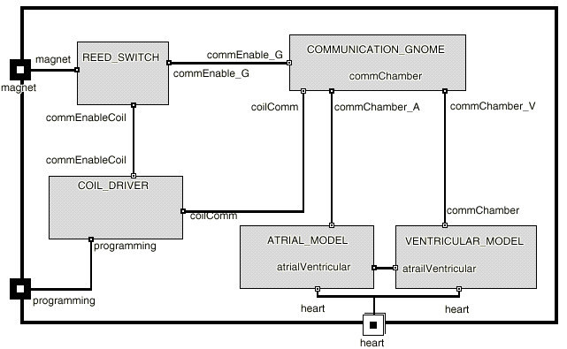
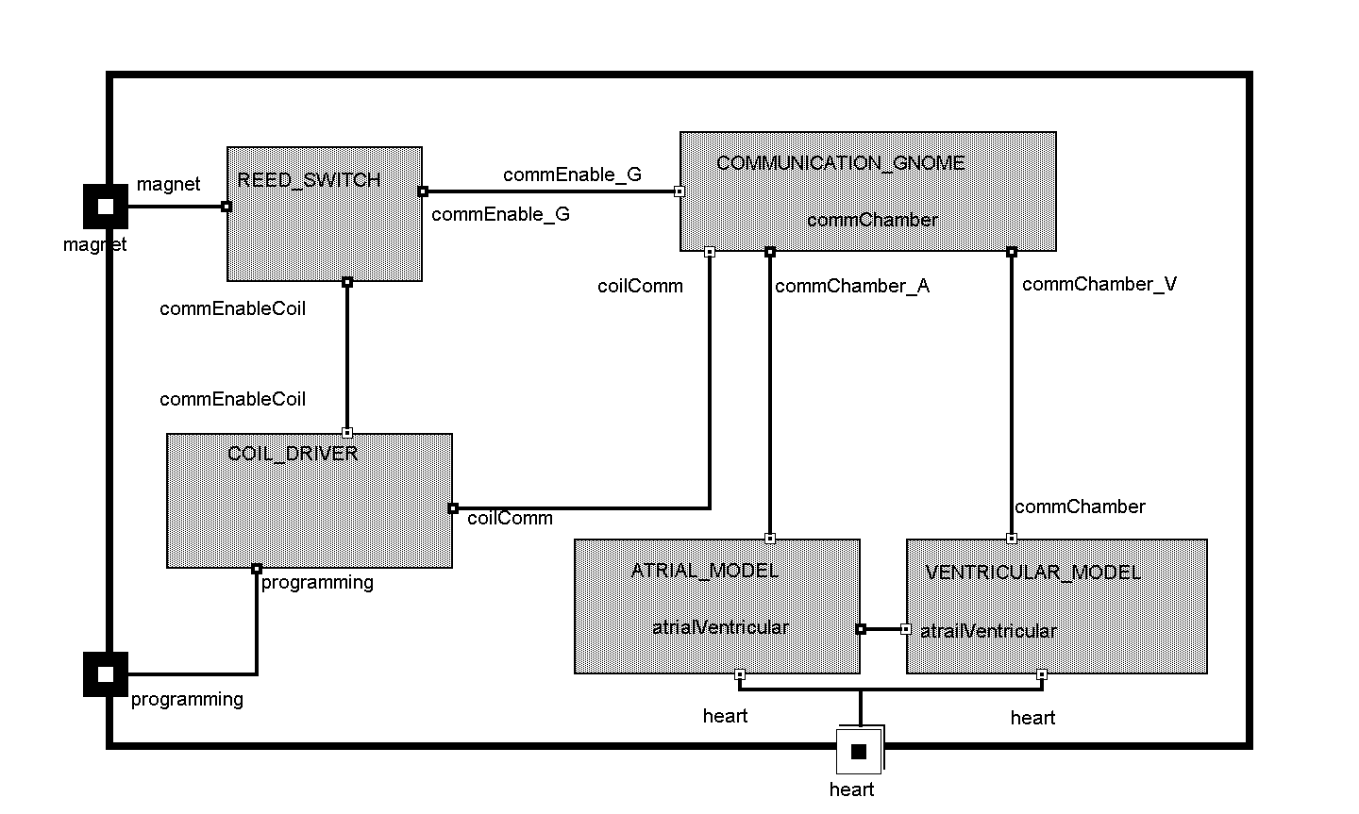
Figure 1 Actor diagram for the Pacemaker.

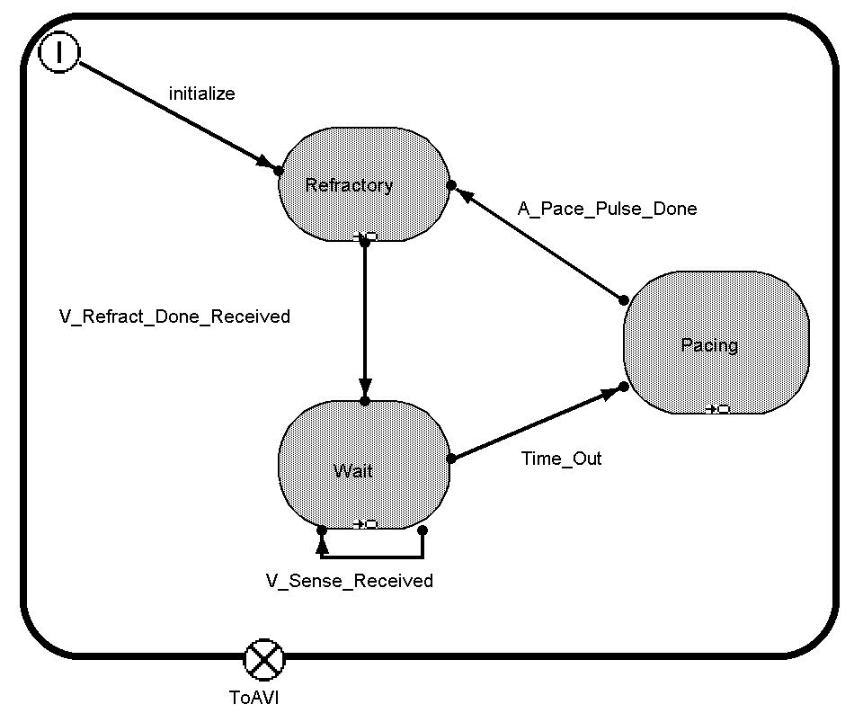

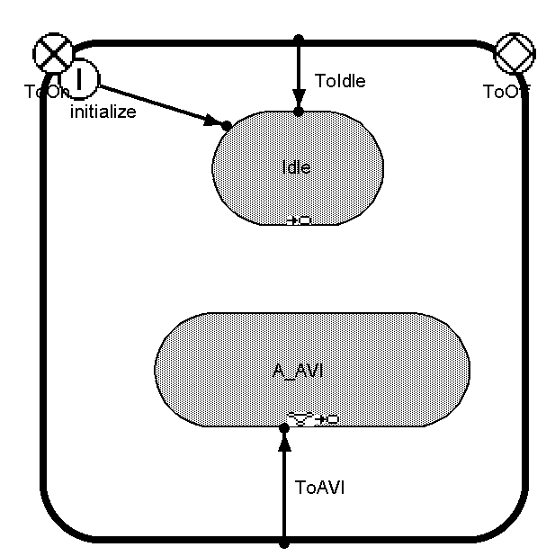
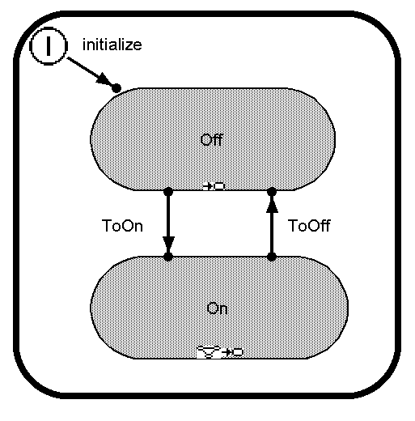

Figure 2 ROOMchart for Atrial_Model

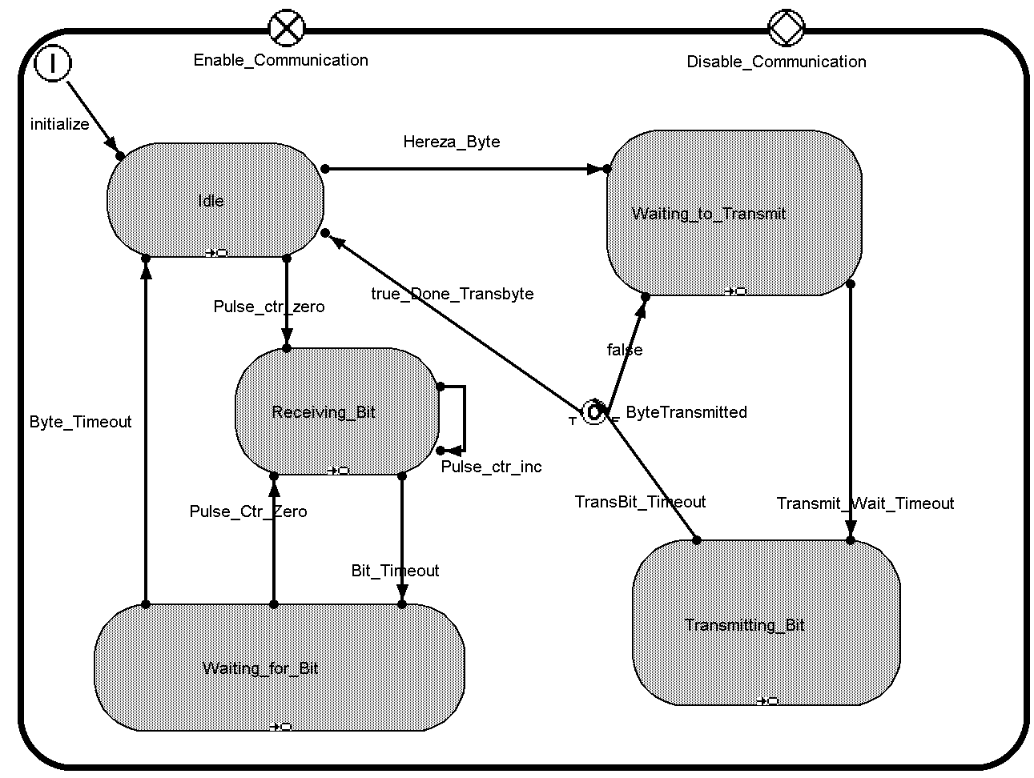

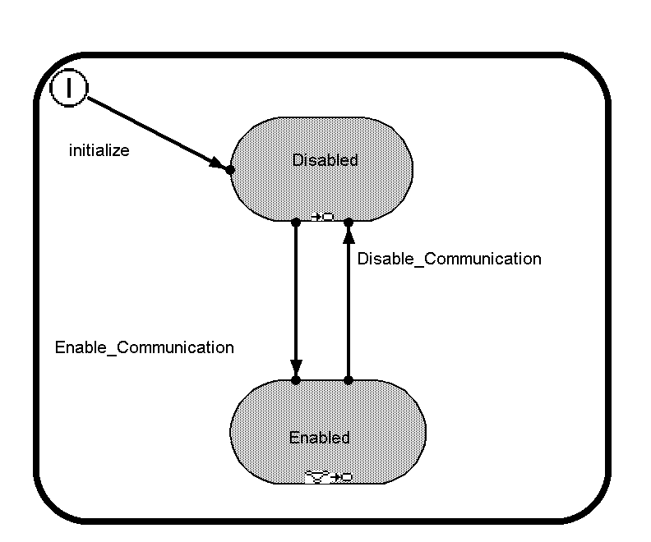

Figure 3 ROOMchart for Coil Driver

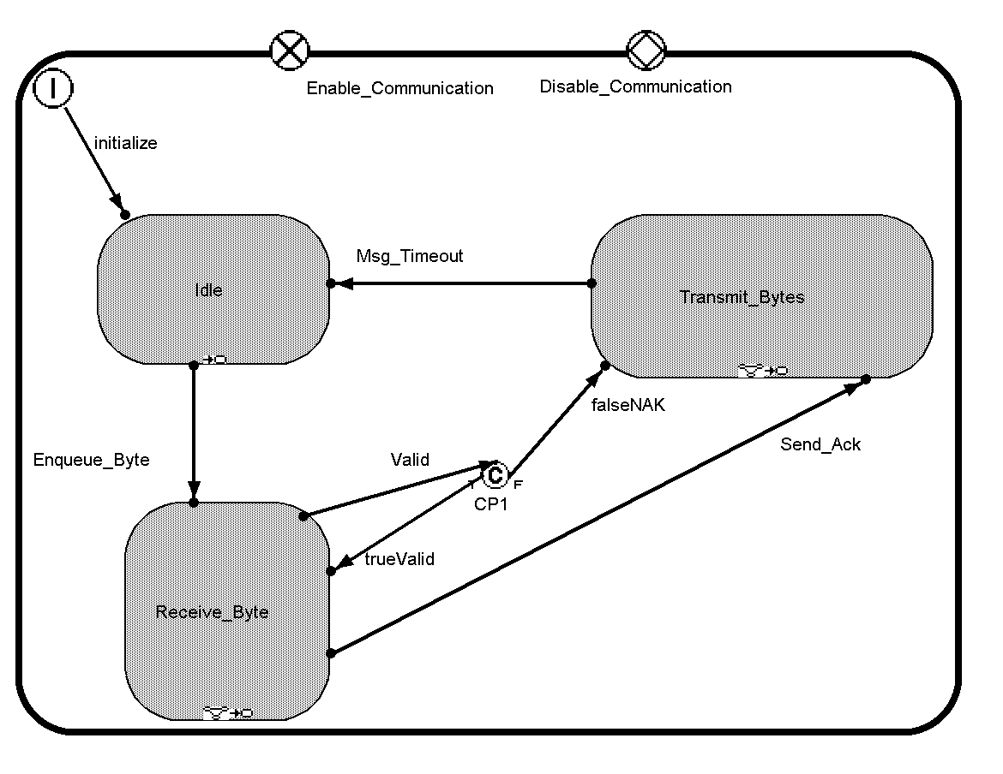

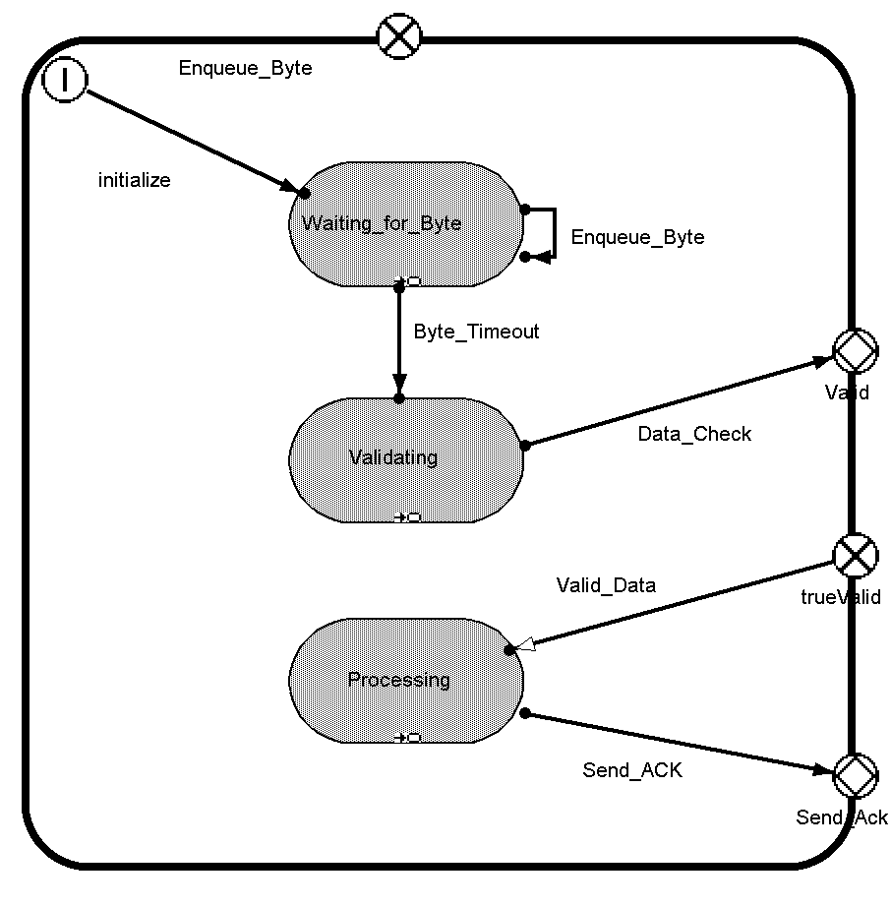
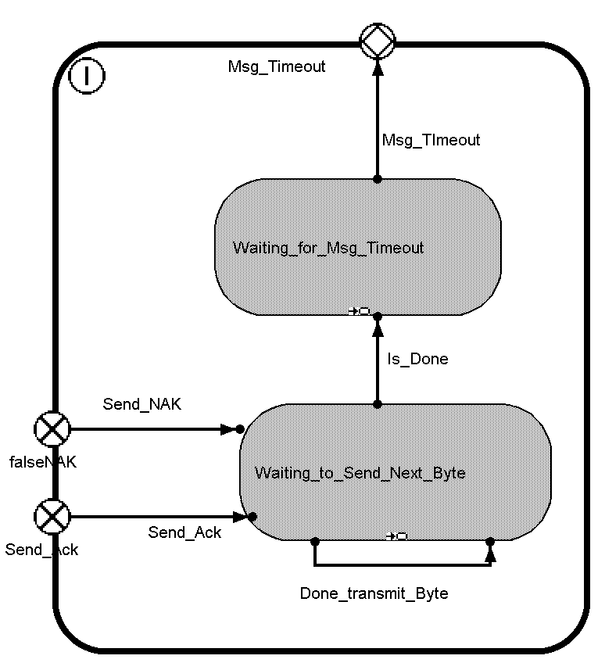

Figure 4 ROOMchart for Communication Gnome

- Sequence diagram for programming mode.

In this scenario the programmer sets the operation mode of the device. The programmer applies a magnet to enable communication with the device, and then he sends pulses to the device, which in turn interprets these pulses into programming bits. The device then send back the data to acknowledge valid/invalid program.

2- Sequence diagrams AVI operation
In this scenario, the Ventricular_Model monitors the heart. When a heartbeat is not sensed, the Artial_Model paces the heart and a refractory period is then in effect.

- Program Atrial_Molel and Ventricular_Model to AVI mode.

- Sequence in case of sensing a heartbeat at the Ventricular “Got V Sense”.

- Sequence in case of not sensing a heartbeat at the Ventricular “sense timeout”.

3- Sequence diagrams AAI operation

In this scenario, the Ventricular_Model Idle and the Artial_Model senses the heart. When a heartbeat is not sensed, the Artial_Model paces the heart and a refractory period is then in effect.

- Program Atrial_Molel and Ventricular_Model to AAI mode.

- Sequence in case of sensing a heartbeat at the Atrial “Got A Sense”.
- Sequence in case of not sensing a heartbeat at the Atrial “sense timeout”.
4- Sequence diagrams AAT operation

In this scenario, the Ventricular_Model Idle and the Artial_Model senses and paces the heart. When a heartbeat is sensed or not sensed, the Artial_Model paces the heart and a refractory period is then in effect.
- Program Atrial_Molel and Ventricular_Model to AAT mode.

- Sequence in case of sensing a heartbeat at the Atrial “Got A Sense”.

- Sequence in case of not sensing a heartbeat at the Atrial “sense timeout”.

